**WORK INSTRUCTIONS FOR** **HYDRAULIC DRILL MACHINE OPERATION**

**Responsibility: Furnace In charge /foreman/ Tap hole operator**

**Hazards identified**

1. Contact with hot metal& slag
2. Fall of Person
3. Impact with drill machine
4. No use of PPE & non-adherence of WI
5. Improper house keeping
6. Inadequate local lighting
7. Misjudgment of swiveling area of drill machine
8. Hose pipe bursting & fire.
9. Cleaning of sand from the runner during drilling operation
10. Viewing whether tap hole drilling is straight or not by stepping on the skimmer plate.
11. Slipping on Oil spillage
12. Flying of red-hot drill bit if it is rotated in red hot condition.
13. Bursting of hydraulic oil pipes
14. Panel remaining ON even when key is removed
15. Hit of spanner/ tool while removing drill after operation
16. Fall of material
17. Use of non-standard tools
18. Power trip during drill operation

**Significant Aspect:**

Noise Generation

Dust Generation

Oil spillages.

**Procedure for Hydraulic Drill Machine operation**

1. Unauthorized operation or repair of any equipment is a punishable offence.
2. Ensure that all the personnel working in the area wearing PPEs (viz. Safety helmets, safety shoes, hand gloves, safety goggles woolen Patti)
3. Remove all the personnel from swing area of the drill machine and mud gun before starting of the hydraulic system. Barricade the drill machine and mud gun swing area before starting the drilling or Mud gun operation.
4. Ensure, other workmen in cast house at far end/ back side while doing reverse operation of drill bit.
5. If at all there is a bend/twist in the pipe in front of the face plate hole, then the pipe to be removed from the shank manually by spanner.
6. Ensure drilling center is as per the tap hole gauge rod.
7. Drill machine operation sequence.

Check the drilling machine angle and ensure it is maintained at 100 once in a shift.

* 1. Ensure Drilling machine operating panel, switch buttons are in place and in healthy condition. Broken/missing push button should be replaced / rectified immediately.
  2. Check the drill bit for welding defects, drill bit tip, straightness of the drill bit.
  3. Drill bit face plate shall be maintained properly for supporting the drill bit.
  4. Ensure there is no leakage in hydraulic hoses/ in the system before operating the system.
  5. Check for power supply indication on the control station.
  6. Open the flushing air ball valve provided nearer to drilling machine panel.
  7. Release the main stop push button.
  8. Select Tap Hole drilling machine operation by turning selector switch towards ‘DRILLER’.
  9. Check for siren operation by pressing ‘Alarm Start’ button & for stopping press ‘Alarm Stop’.
  10. Switch on the hydraulic system. After starting, indication for Pump 1, 2 or 3 whichever is in remote mode will glow.
  11. For taking drilling machine towards taphole press ‘Swivelling Forward’. Release the button when the drill machine reaches taphole.
  12. Start drill bit rotation by pressing button in forward or backward direction for either clockwise or anticlockwise direction. However, while drilling only anticlockwise rotation of the drill bit to be done when viewed facing Tap Hole**.**
  13. Ensure that the drill bit is freely rotating before we move the drill machine in position to drill or at least ensure that drill bit is not touching the tap hole before starting the rotation of the drill bit.
  14. Ensure drill bit changing is done by removing lockable key in Off position only. (Responsibility: foreman/tap hole operator)
  15. Then move the carriage of drill machine by pressing forward push button for ‘Feeding Forward’ & by pressing backward push button for ‘Feeding Backward’
  16. If impact or hammering of the drill bit is required while rotation, press the impact button switch on panel.
  17. When the first symptom of metal is observed (i.e., when symptom of cast is getting open), take back the drill bit by moving the carriage of the drill machine backward through operation of ‘Feeding Backward’ switch back.
  18. Take the drilling machine backward by operating swiveling backward button till the parking position of the drilling machine is reached.
  19. Stop the hydraulic system by pressing ‘Stop’ push button.
  20. Turn drilling/mud gun selector switch to ‘None’ position.
  21. Press the main stop push button.
  22. Remove the key from the ‘lockable switch’ in off position only.
  23. Close the flushing air valve when drilling machine reaches to parking position.
  24. Tap hole drilling should be done cautiously by moving the drill to and fro on the carriage to avoid jamming of the drill bit or to avoid sudden opening of tap hole.

**Precautions**

* 1. Do not operate drilling machine to make tap hole through.
  2. No person should work on hydraulic drilling machine & mud gun without removing key, key will in the custody of the person who is working. After finishing the job on particular equipment, key should be handed over to the operational person
  3. No personnel are allowed to stand in the swing area of the drill machine while the drilling the tap hole.
  4. Ensure that hot / burnt drill bit is replaced in cold condition if not then call the fitter to replace it & keep the drill machine area clean. Ensure that emergency push button is pushed(stopped) which is near to the drill machine in addition to that also ensure no person operates it from the drill machine/mud gun console panel. For drill bit which is not hot can be replaced by holding at the center point of the drill bit from the shaft and the face plate ,so that it does not fall due to imbalance and rotate it anti clockwise and remove it from the shaft .new drill bit can be fitted to the shaft on similar basis rotating the drill bit clockwise .If it cannot be removed manually fitter to be called to remove the same
  5. Use drill bit having dia above 45mm
  6. Take back drill after every 400 to 600 mm drilling and check whether drill bit is worn below pipe dia or bent along the length.
  7. Remove the drill bit when the dia of the cutting bit reduces to less than or equal the dia of drill pipe. (As it will increase the load /strain on the machine).
  8. Inspect the drill bit pipe during operation by taking the drill bit frequently backward. If fresh circular markings are observed, it is clear that the drill bit dia is reduced. Replace the drill bit to new one. If there is circular marking on pipe it reflects rubbing of pipe during rotation.
  9. If any symptom of cast is getting opened or metal sparks found, remove hollow drill bit and use solid rod drill bit alternatively if the taphole has drilled upto one meter then the drill bit may be changed to solid drill. For opening solid drill bit only to be used.
  10. During the drilling operation if the drill bit is not rotating/ has got stuck in the tap hole, stop the rotation of the drill bit, reverse the carriage by hammering for once or twice and if the drill bit is not coming out lance the drill bit for easy extraction.
  11. After drilling, red hot drill bit should not be rotated to avoid flying of red-hot drill bit tip (flying drill bit may injure the people staying in the vicinity of the drilling machine).
  12. In case the drill bit pipe gets stuck in the machine shaft then the same to be removed through the service dept. or Maintenance Dept. Operation person should not attempt to remove it using hydraulic/Pneumatic energy.
  13. Non-standard tool or any tool which is not approved should not be used
  14. Flushing air should not be stopped till operation of drilling machine is finished and the machine is taken back to the parking position.
  15. Idle running of the machine should be avoided.
  16. Ensure that two pumps should be in Remote mode at panel and butterfly valve for the same should be open in hydraulic power pack room. Pump no: 2 is provided with on/off selection at operator control desk. For normal operation only one pump will be in line. In case of additional pump requirement pump, no: 2 can be started from the control desk by operating selector switch for pump no: 2 to on position.
  17. In case of problem with running pump or in case of changeover, Electrical should be contacted for doing required pump selection at panel in hydraulic power pack room. Two pumps shall be started only in case of emergency like jamming of Mudgun /Drill machine in front tap hole, slow operation of drill bit, etc.

Photos of drill bit damage and pipe getting rubbed.

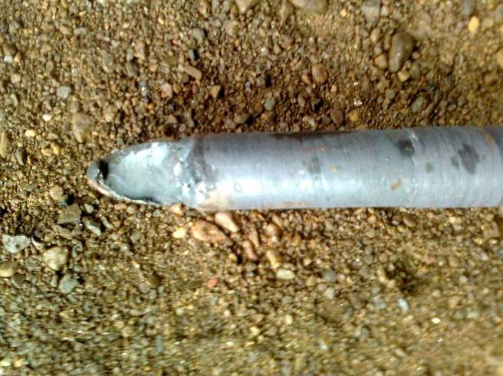 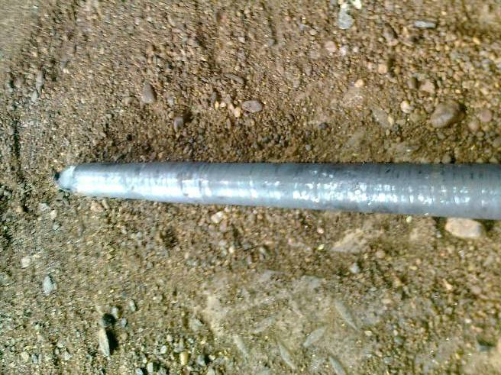

Workmen of production or mechanical fitter wants to work on Mud gun/Drill machine then he has to follow the below steps.

1. Keep mud gun/drill machine rotary selection switch in off position.

2. Turn the lockable emergency key switch to off position and remove the key. Ensure healthiness of key switch for coming out in off position at least once in shift.

3. Press main emergency stop push button.

4. After doing all above 1,2 & 3 steps operator should cross check and conform that any Mud gun or Drill machine operation are not taking place.

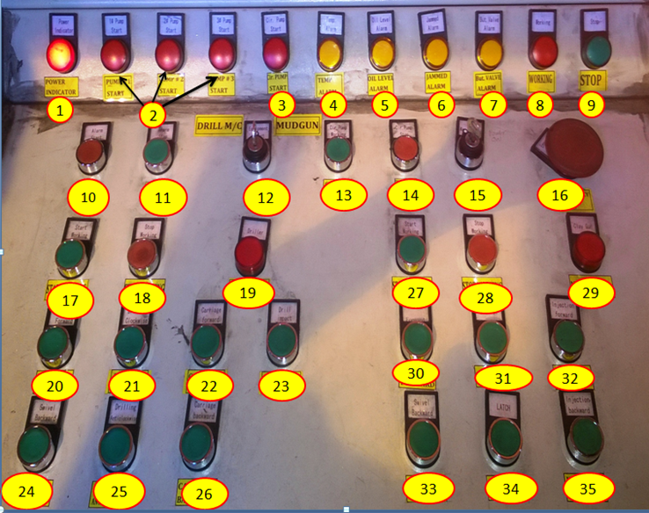

|  |  |  |  |  |  |
| --- | --- | --- | --- | --- | --- |
| **1** | Power Indicator | **13** | Circulation pump start | **25** | Drilling Anticlockwise |
| **2** | Pump On indications | **14** | Circulation pump stop | **26** | Carriage backward |
| **3** | Circulation Pump | **15** | Panel On/Off key | **27** | Mudgun start |
| **4** | Temperature Alarm | **16** | Emergency stop | **28** | Mudgun stop |
| **5** | Oil Level Alarm | **17** | Start drill machine | **29** | Mudgun on indication |
| **6** | Jammed Alarm | **18** | Stop Drill Machine | **30** | Mudgun swivel forward |
| **7** | Butterfly Valve Alarm | **19** | Drill Machine on | **31** | Unlatch |
| **8** | Working Indication | **20** | Drill M/C Swivel forward | **32** | Injection forward |
| **9** | Stop Indication | **21** | Drilling Clockwise | **33** | Swivel Backward |
| **10** | Alarm Start | **22** | Carriage forward | **34** | Latch |
| **11** | Alarm Stop | **23** | Impact drilling | **35** | Injection backward |
| **12** | Drill/ Mud Gun selector | **24** | Drill M/C swivel back word |  |  |

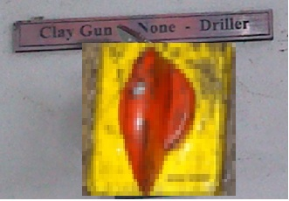

Equipment Selector Switch

For selecting Clay Gun or Drill Machine

Mud gun/drilling alarm setting:

1. Recirculation pump for oil cooling will start automatically when oil temperature reaches 45°C and will stop in auto when temperatures comes down to 40°C.
2. High temperature alarm will appear in control desk at cast house and at control room PC when the temperature reaches 50°C. Cast house engineer/ control room engineer has to inform Shift mechanical engineer when this alarm is appeared.
3. Oil level low alarm will appear in control desk at cast house and at control room PC when oil quantity in power pack is below 1765 liters. Cast house engineer/ control room engineer has to inform Shift mechanical engineer when this alarm is appeared.
4. Oil High level alarm will appear in control desk at cast house and at control room PC when oil quantity in power pack is above 2000 liters. Cast house engineer/ control room engineer has to inform Shift mechanical engineer when this alarm is appeared. Oil level low alarm will appear in control desk at cast house and at control room PC when oil quantity in power pack is below 1472 liters. At this moment operating of the equipment may lead to stoppage in between of the operation will lead to damage of the equipment. Cast house engineer/ control room engineer has to inform Shift mechanical engineer when this alarm is appeared and not to be operated.
5. If any problem due to mechanical / electrical, Service department may operate the equipment on the permission of furnace in charge / SS from the power pack with co-ordination of furnace in charge by ensuring nobody are in the vicinity of drilling machine / mud gun swiveling area.

|  |  |
| --- | --- |
| Technical parameters | |
| Drilling Mechanism | |
| Drilling diameter ranges | 35 -40 mm |
| Rotator speed of drilling | ~300 r/min |
| Range of drill inclination | Current:100 |
| Range: 60~160 |
| Impact energy | 350 J |
| Rotator Torque | 460 N.m |
| Max Drilling depth | 2000 mm |
| Frequency of impact | 40~50 HZ |
| Operating pressure | 13MPa |
| Operating flow | rotator:70 L/min |
|  | impact:90 L/min |
| Swivelling mechanism | |
| Swivelling angle | 1000 |
| Drilling mechanism swing angle | 1680 |
| Swivelling Time | 12~14 S |
| Operating pressure | 13 MPa |
| Operating flow | 35~75 L/min |
| Hammer carriage unit | |
| Speed carriage movement | Forward: 0.025~ 0.05 m/s |
| Backward: 1m/s |
| Operating pressure | 13 MPa |
| Operating flow | Forward: 4L/min |
| Backward: 80L/min |
| Flushing Air | |
| Operating pressure | 0.5~1.2 Mpa |

**Work Instruction for Drill machine Operation (BF2)**

**Criteria: Safe Handling of equipment, Safe work practices in the Cast house**

**Responsibility: Furnace Incharge/Taphole operator**

**Objective: Safe Handling of equipment, Safe work practices in the Cast house**

**Responsibility: Furnace In charge /foreman/Sr. Tap hole operator**

**Hazards:**

1. Contact with hot metal& slag
2. Fall of Person
3. Impact with drill machine
4. No use of PPE & non adherence of WI
5. Improper house keeping
6. Inadequate local lighting
7. Misjudgment of swiveling area of drill machine
8. Hose pipe bursting & fire.
9. Cleaning of sand from the runner during drilling operation
10. Viewing whether tap hole drilling is straight or not by stepping on the skimmer plate.
11. Slipping on Oil spillage
12. Flying of red hot drill bit if it is rotated in red hot condition.
13. Bursting of hydraulic oil pipes
14. Panel remaining ON even when key is removed
15. Hit of spanner/ tool while removing drill after operation
16. Fall of material
17. Use of non-standard tools

**Behavioral :**

1. Changing drill bit without removing lockable key.
2. Movement of drilling machine when mud gun machine in front of tap hole and vice versa.
3. Ignorance of alarms related to oil level and oil temperature.
4. Operation of mud gun / drilling machine without ensuring siren is blown.

Mechanical :

1. Failure of mud / drilling machine during cast opening at tap hole.

**Significant Aspect:**

Noise Generation

Dust Generation

Oil spillage.

**Procedure for Hydraulic Drill Machine operation**

1. Unauthorized operation or repair of any equipment is a punishable offence.
2. Ensure that all the personnel working in the area wearing PPEs (viz: Safety helmets, safety shoes, hand gloves, safety goggles woolen Patti)
3. Remove all the personnel from swing area of the drill machine and mud gun before starting of the hydraulic system. Barricade the drill machine and mud gun swing area before starting the drilling or Mud gun operation.
4. Ensure drilling center is as per the tap hole gauge rod.
5. Drill machine operation sequence.

Check the drilling machine angle and ensure it is maintained at 100 once in a shift.

* 1. Ensure Drilling machine operating panel, switch buttons are in place and in healthy condition. Broken/missing push button should be replaced / rectified immediately.
  2. Check the drill bit for welding defects, drill bit tip, straightness of the drill bit.
  3. Drill bit face plate shall be maintained properly for supporting the drill bit.
  4. Ensure there is no leakage in hydraulic hoses/ in the system before operating the system.
  5. Check for power supply indication on the control station.
  6. Open the flushing air ball valve provided nearer to drilling machine panel.
  7. Release the main stop push button.
  8. Select Tap Hole drilling machine operation by turning selector switch towards ‘DRILLER’.
  9. Check for siren operation by pressing ‘Alarm Start’ button & for stopping press ‘Alarm Stop’.
  10. Switch on the hydraulic system. After starting, indication for Pump 1, 2 or 3 whichever is in remote mode will glow.
  11. For taking drilling machine towards taphole move ‘Swivelling Forward’ joystick very slowly. Release the joystick when the drill machine reaches taphole.
  12. Start drill bit rotation by moving joystick in forward or backward direction for either clockwise or anticlockwise direction. However while drilling only anticlockwise rotation of the drill bit to be done when viewed facing Tap Hole.
  13. Ensure that the drill bit is freely rotating before we move the drill machine in position to drill or at least ensure that drill bit is not touching the tap hole before starting the rotation of the drill bit.
  14. Ensure drill bit changing is done by removing lockable key in Off position only. (Responsibility: Fitter)
  15. Then move the carriage of drill machine by pressing forward push button for ‘Feeding Forward’ & by pressing backward push button for ‘Feeding Backward’
  16. If impact or hammering of the drill bit is required while rotation, press the impact button switch on panel.
  17. When the first symptom of metal is observed (i.e. when symptom of cast is getting open), take back the drill bit by moving the carriage of the drill machine backward through operation of ‘Feeding Backward’ joystick back.
  18. Take the drilling machine backward by operating swiveling backward lever slowly till the parking position of the drilling machine is reached.
  19. Stop the hydraulic system by pressing ‘Stop’ push button.
  20. Turn drilling/mud gun selector switch to ‘None’ position.
  21. Press the main stop push button.
  22. Remove the key from the ‘lockable switch’ in off position only.
  23. Close the flushing air valve when drilling machine reaches to parking position.
  24. Tap hole drilling should be done cautiously by moving the drill to and fro on the carriage to avoid jamming of the drill bit or to avoid sudden opening of tap hole.
  25. **Precautions**
  26. Do not operate drilling machine to make tap hole through.
  27. No person should work on hydraulic drilling machine & mud gun without removing key, key will in the custody of the person who is working. After finishing the job on particular equipment, key should be handed over to the operational person
  28. No personnel are allowed to stand in the swing area of the drill machine while the drilling the tap hole.
  29. Ensure that hot / burnt drill bit is replaced in cold condition if not then call the fitter to replace it & keep the drill machine area clean. Ensure that emergency push button is pushed(stopped) which is near to the drill machine in addition to that also ensure no person operates it from the drill machine/mudgun console panel. For drill bit which is not hot can be replaced by holding at the center point of the drill bit from the shaft and the face plate ,so that it does not fall due to inbalance and rotate it anti clockwise and remove it from the shaft .new drill bit can be fitted to the shaft on similar basis rotating the drill bit clockwise .If it cannot be removed manually fitter to be called to remove the same
  30. Use drill bit having dia. above 45mm
  31. Take back drill after every 400 to 600 mm drilling and check whether drill bit is worn below pipe dia. or bent along the length.
  32. Remove the drill bit when the dia. of the cutting bit reduces to less than or equal the dia. of drill pipe as it will increase the load /strain on the machine).
  33. Inspect the drill bit pipe during operation by taking the drill bit frequently backward. If fresh circular markings are observed, it is clear that the drill bit dia. is reduced. Replace the drill bit to new one. If there is circular marking on pipe it reflects rubbing of pipe during rotation.
  34. If any symptom of cast is getting opened or metal sparks found, remove hollow drill bit and use solid rod drill bit alternatively if the tap hole has drilled up to one meter then the drill bit may be changed to solid drill. For opening solid drill bit only to be used.
  35. During the drilling operation if the drill bit is not rotating/ has got stuck in the tap hole, stop the rotation of the drill bit, reverse the carriage by hammering for once or twice and if the drill bit is not coming out lance the drill bit for easy extraction.
  36. After drilling, red hot drill bit should not be rotated to avoid flying of red hot drill bit tip (flying drill bit may injure the people staying in the vicinity of the drilling machine).
  37. In case the drill bit pipe get stuck in the machine shaft then the same to be removed through the service dept. or Maintenance Dept. Operation person should not attempt to remove it using hydraulic/Pneumatic energy.
  38. Non-standard tool or any tool which is not approved should not be used
  39. Flushing air should not be stopped till operation of drilling machine is finished and the machine is taken back to the parking position.
  40. Idle running of the machine should be avoided.
  41. Ensure that two pumps should be in Remote mode at panel and butterfly valve for the same should be open in hydraulic power pack room. Pump no: 2 is provided with on/off selection at operator control desk. For normal operation only one pump will be in line. In case of additional pump requirement pump no:2 can be started from the control desk by operating selector switch for pump no: 2 to on position.
  42. In case of problem with running pump or in case of changeover, Electrical should be contacted for doing required pump selection at panel in hydraulic power pack room.

Two pumps shall be started only in case of emergency like jamming of Mudgun/Drill machine in front taphole, slow operation of drill bit, etc.

Photos of drill bit damage and pipe getting rubbed.

 

Workmen of production or mechanical fitter wants to work on Mud gun/Drill machine then he has to follow below steps,

1. Keep mud gun/drill machine rotary selection switch in off position.

2. Turn the lockable emergency key switch to off position and remove the key .Ensure healthiness of key switch for coming out in off position at least once in shift.

3. Press main emergency stop push button.

4. After doing all above 1,2 & 3 steps operator should cross check and conform that any Mud gun or Drill machine operation are not taking place.

**Work Instruction for Operation of Hydraulic Drill machine (BF2)**

**Objective: Safe Handling of equipment, Safe work practices in the Cast house**

**Responsibility: Furnace In charge /foreman/Sr. Tap hole operator**

**Hazards:**

1. Contact with hot metal& slag
2. Fall of Person
3. Impact with drill machine
4. No use of PPE & non adherence of WI
5. Improper house keeping
6. Inadequate local lighting
7. Misjudgment of swiveling area of drill machine
8. Hose pipe bursting & fire.
9. Cleaning of sand from the runner during drilling operation
10. Viewing whether tap hole drilling is straight or not by stepping on the skimmer plate.
11. Slipping on Oil spillage
12. Flying of red hot drill bit if it is rotated in red hot condition.
13. Bursting of hydraulic oil pipes
14. Panel remaining ON even when key is removed
15. Hit of spanner/ tool while removing drill after operation
16. Fall of material
17. Use of non-standard tools

**Behavioral :**

1. Changing drill bit without removing lockable key.
2. Movement of drilling machine when mud gun machine in front of tap hole and vice versa.
3. Ignorance of alarms related to oil level and oil temperature.
4. Operation of mud gun / drilling machine without ensuring siren is blown.

Mechanical :

1. Failure of mud / drilling machine during cast opening at tap hole.

**Significant Aspect:**

Noise Generation

Dust Generation

Oil spillage.

**Procedure for Hydraulic Drill Machine operation**

1. Unauthorized operation or repair of any equipment is a punishable offence.
2. Ensure that all the personnel working in the area wearing PPEs (viz: Safety helmets, safety shoes, hand gloves, safety goggles woolen Patti)
3. Remove all the personnel from swing area of the drill machine and mud gun before starting of the hydraulic system. Barricade the drill machine and mud gun swing area before starting the drilling or Mudgun operation.
4. Ensure drilling centre is as per the tap hole gauge rod.
5. Drill machine operation sequence.

Check the drilling machine angle and ensure it is maintained at 100 once in a shift.

* 1. Ensure Drilling machine operating panel, switch buttons are in place and in healthy condition. Broken/missing push button should be replaced / rectified immediately.
  2. Check the drill bit for welding defects, drill bit tip, straightness of the drill bit.
  3. Drill bit face plate shall be maintained properly for supporting the drill bit.
  4. Ensure there is no leakage in hydraulic hoses/ in the system before operating the system.
  5. Check for power supply indication on the control station.
  6. Open the flushing air ball valve provided nearer to drilling machine panel.
  7. Release the main stop push button.
  8. Select Tap Hole drilling machine operation by turning selector switch towards ‘DRILLER’.
  9. Release drilling machine stop push button.
  10. Check for siren operation by pressing ‘Alarm Start’ button & for stopping press ‘Alarm Stop’.
  11. Switch on the hydraulic system. After starting, indication for Pump 1, 2 or 3 whichever is in remote mode will glow.
  12. For taking drilling machine towards taphole press the push button ‘Swivelling Forward’ very slowly. Release the push button when the drill machine reaches taphole.
  13. Start drill bit rotation by pressing the anti clockwise / clock wise push button for rotation in anit clockwise/clockwise direction. However while drilling only anticlockwise rotation of the drill bit to be done when viewed facing Tap Hole.
  14. Ensure that the drill bit is freely rotating before we move the drill machine in position to drill or at least ensure that drill bit is not touching the tap hole before starting the rotation of the drill bit.
  15. Ensure drill bit changing is done by removing lockable key in Off position only. (Responsibility: Fitter)
  16. Then move the carriage of drill machine by pressing forward push button for ‘Feeding Forward’ & by pressing backward push button for ‘Feeding Backward’
  17. If impact or hammering of the drill bit is required while rotation, press the impact button switch on panel.
  18. When the first symptom of metal is observed (i.e. when symptom of cast is getting open), take back the drill bit by moving the carriage of the drill machine backward through operation of ‘Feeding Backward’ push button.
  19. Take the drilling machine backward by operating swiveling backward lever slowly till the parking position of the drilling machine is reached.
  20. Stop the hydraulic system by pressing ‘Stop’ push button.
  21. Turn drilling/mud gun selector switch to ‘None’ position.
  22. Press the main stop push button.
  23. Remove the key from the ‘lockable switch’ in off position only.
  24. Close the flushing air valve when drilling machine reaches to parking position.
  25. Tap hole drilling should be done cautiously by moving the drill to and fro on the carriage to avoid jamming of the drill bit or to avoid sudden opening of tap hole.
  26. **Precautions**
  27. Do not operate drilling machine to make tap hole through.
  28. No person should work on hydraulic drilling machine & mud gun without removing key, key will in the custody of the person who is working. After finishing the job on particular equipment, key should be handed over to the operational person
  29. No personnel are allowed to stand in the swing area of the drill machine while the drilling the taphole.
  30. Ensure that hot / burnt drill bit is replaced in cold condition if not then call the fitter to replace it & Keep the drill machine area clean.Ensure that emergency push button is pushed(stopped) which is near to the drill machine in adition to that also ensure no person operates it from the drill machine/mudgun console panel. For drill bit which is not hot can be replaced by holding at the center point of the drill bit from the shaft and the face plate ,so that it does not fall due to inbalance and rotate it anti clockwise and remove it from the shaft .new drill bit can be fitted to the shaft on similar basis rotating the drill bit clockwise .If it cannot be removed manually fitter to be called to remove the same
  31. Use drill bit having dia above 45mm
  32. Take back drill after every 400 to 600 mm drilling and check whether drill bit is worn below pipe dia or bent along the length.
  33. Remove the drill bit when the dia of the cutting bit reduces to less than or equal the dia of drill pipe.(as it will increase the load /strain on the machine).
  34. Inspect the drill bit pipe during operation by taking the drill bit frequently backward. If fresh circular markings are observed, it is clear that the drill bit dia is reduced. Replace the drill bit to new one. If there is circular marking on pipe it reflects rubbing of pipe during rotation.
  35. If any symptom of cast is getting opened or metal sparks found, remove hollow drill bit and use solid rod drill bit alternatively if the tap hole has drilled up to one meter then the drill bit may be changed to solid drill. For opening solid drill bit only to be used.
  36. During the drilling operation if the drill bit is not rotating/ has got stuck in the tap hole, stop the rotation of the drill bit, reverse the carriage by hammering for once or twice and if the drill bit is not coming out lance the drill bit for easy extraction.
  37. After drilling, red hot drill bit should not be rotated to avoid flying of red hot drill bit tip (flying drill bit may injure the people staying in the vicinity of the drilling machine).
  38. In case the drill bit pipe get stuck in the machine shaft then the same to be removed through the service dept. or Maintenance Dept. Operation person should not attempt to remove it using hydraulic/Pneumatic energy.
  39. Non-standard tool or any tool which is not approved should not be used
  40. Flushing air should not be stopped till operation of drilling machine is finished and the machine is taken back to the parking position.
  41. Idle running of the machine should be avoided.
  42. Ensure that two pumps should be in Remote mode at panel and butterfly valve for the same should be open in hydraulic power pack room. Pump no: 2 is provided with on/off selection at operator control desk. For normal operation only one pump will be in line. In case of additional pump requirement pump no: 2 can be started from the control desk by operating selector switch for pump no: 2 to on position.
  43. In case of problem with running pump or in case of changeover, Electrical should be contacted for doing required pump selection at panel in hydraulic power pack room.

Two pumps shall be started only in case of emergency like jamming of Mudgun/Drill machine in front tap hole, slow operation of drill bit, etc. .

Photos of drill bit damage and pipe getting rubbed.

 

Workmen of production or mechanical fitter wants to work on Mudgun/Drill machine then he has to follow below steps.

1. Keep mudgun/drill machine rotary selection switch in off position.

2. Turn the lockable emergency key switch to off position and remove the key .Ensure healthiness of key switch for coming out in off position at least once in shift.

3. Press main emergency stop push button.

4. After doing all above 1,2 & 3 steps operator should cross check and conform that any Mudgun or Drill machine operation are not taking place.

Mud gun/drilling alarm setting:

1. Recirculation pump for oil cooling will start automatically when oil temperature reaches 45°C and will stop in auto when temperatures comes down to 40°C.
2. High temperature alarm will appear in control desk at cast house and at control room PC when the temperature reaches 50°C. Cast house engineer/ control room engineer has to inform Shift mechanical engineer when this alarm is appeared.
3. Oil level low alarm will appear in control desk at cast house and at control room PC when oil quantity in power pack is below 1765 liters. Cast house engineer/ control room engineer has to inform Shift mechanical engineer when this alarm is appeared.
4. Oil High level alarm will appear in control desk at cast house and at control room PC when oil quantity in power pack is above 2000 liters. Cast house engineer/ control room engineer has to inform Shift mechanical engineer when this alarm is appeared. Oil level low alarm will appear in control desk at cast house and at control room PC when oil quantity in power pack is below 1472 liters. At this moment operating of the equipment may lead to stoppage in between of the operation will lead to damage of the equipment. Cast house engineer/ control room engineer has to inform Shift mechanical engineer when this alarm is appeared and not to be operated.
5. If any problem due to mechanical / electrical, Service department may operate the equipment on the permission of furnace in charge / SS from the power pack with co-ordination of furnace in charge by ensuring nobody are in the vicinity of drilling machine / mud gun swiveling area.

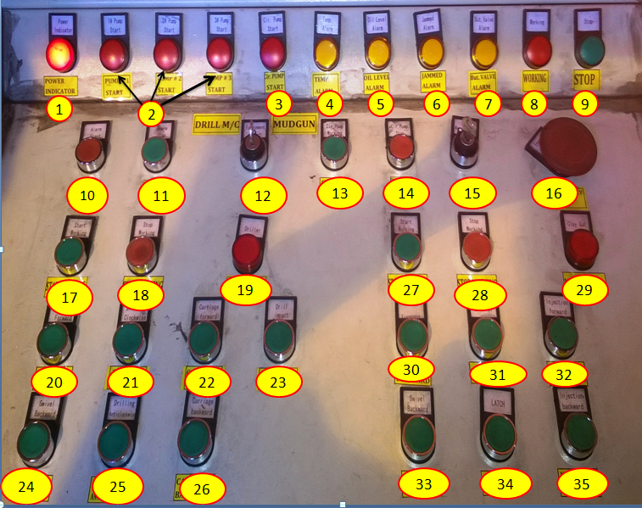

|  |  |  |  |  |  |
| --- | --- | --- | --- | --- | --- |
| **1** | Power Indicator | **13** | Circulation pump start | **25** | Drilling Anticlockwise |
| **2** | Pump On indications | **14** | Circulation pump stop | **26** | Carriage backward |
| **3** | Circulation Pump | **15** | Panel On/Off key | **27** | Mudgun start |
| **4** | Temperature Alarm | **16** | Emergency stop | **28** | Mudgun stop |
| **5** | Oil Level Alarm | **17** | Start drill machine | **29** | Mudgun on indication |
| **6** | Jammed Alarm | **18** | Stop Drill Machine | **30** | Mudgun swivel forward |
| **7** | Butterfly Valve Alarm | **19** | Drill Machine on | **31** | Unlatch |
| **8** | Working Indication | **20** | Drill M/C Swivel forward | **32** | Injection forward |
| **9** | Stop Indication | **21** | Drilling Clock wise | **33** | Swivel Backward |
| **10** | Alarm Start | **22** | Carriage forward | **34** | Latch |
| **11** | Alarm Stop | **23** | Impact drilling | **35** | Injection backward |
| **12** | Drill/ Mud Gun selector | **24** | Drill M/C swivel back ward |  |  |

|  |  |  |
| --- | --- | --- |
| **Prepared By:**  Head – Production PID I | **Reviewed & Issued By:**  Management Representative | **Approved By:**  Head – Pig Iron Division |
| **Signature:** | **Signature:** | **Signature:** |
| **Date: 15.07.2022** | **Date: 15.07.2022** | **Date: 15.07.2022** |

|  |  |  |  |
| --- | --- | --- | --- |
| **Amendment Record** | | | |
| **Revision date** | **Manual Section ref. and para** | **Brief details of revision** | **New Revision No.** |
| 15.07.2022 | Work instructions for operation of Hydraulic drill machine | Hazard identified | 13 |